Scope Management plan
Barangay Bahay Toro Health Information System: A Community Based Approach to Improve Access to Primary Healthcare

Project Documentation Submitted to the Faculty of
Bachelor of Science in Information Technology
College of Computer Studies
Bestlink College of the Philippines

In Partial Fulfillment of the Requirements for
PM101 – PROJECT MANAGEMENT

Prepared By: BHC Company
Client: Mr. Adrian Joson

Project Manager: Arbolante, Jeffrey
Project Coordinator: Alberto, Almira
Encoder: Delima, Herbert
Programmer: De Vera, Dionisio Jr.
Project Analyst: Alforon, Jonalyn
UI Designer: Benavidez, John Gave
Developer: Gardoce, Bea
Documentation/Testing: Reyes, Maria Luisa

OCTOBER 2025

Table of Contents
Introduction 4
Scope Management Approach 5
Roles and Responsibilities 5
Scope Definition 7
Project Scope Statement 7
Work Breakdown Structure 8
Scope Verification 9
Scope Control 10
Sponsor Acceptance 11

Introduction
The Scope Management Plan outlines the procedures for defining, validating, and controlling the project scope of the Barangay Bahay Toro Health Information System. This initiative aims to enhance primary healthcare delivery by digitizing health records and streamlining access to patient and community health information. The plan ensures alignment with project goals, minimizes scope creep, and defines responsibilities for scope-related tasks.

Project Scope Management follows a five step process; Collect Requirements, Define Scope, Create WBS, Verify Scope, and Control Scope.

- Collect Requirements – The process of collecting requirements for the Barangay Bahay Toro Health Information System involves identifying the needs and expectations of all stakeholders through a variety of methods. These include conducting interviews with barangay officials and health workers, organizing focus group discussions with community members, distributing surveys, and reviewing existing health documentation and workflows. The goal is to gather clear and complete requirements that reflect the actual needs of the users.
- Define Scope – Once the requirements have been gathered, the scope of the project is clearly defined to outline what is included and excluded. The defined scope for the Barangay Bahay Toro Health Information System includes the design, development, and implementation of the digital system, training sessions for users, data migration from paper records, and post-deployment support for up to six months. The scope explicitly excludes broader regional implementation or any hardware procurement beyond the pilot barangay.
- Create WBS – Creating the Work Breakdown Structure (WBS) involves decomposing the entire scope into smaller, more manageable tasks and work packages. For this project, the WBS is structured into major components such as requirements gathering, system design, development, testing, deployment, and training.
- Verify Scope – Verifying the scope involves reviewing completed deliverables with stakeholders to confirm they meet the originally defined requirements. For the Health Information System project, verification will include user acceptance testing (UAT) with barangay health workers, system walkthroughs with project sponsors and the municipal health office, and formal sign-off on deliverables.
- Control Scope – Scope control is the process of monitoring the project for potential changes and managing those changes in a controlled and documented manner. In this project, any new feature requests or changes to the system must go through a formal change control process.

Scope Management Approach
It is important that the approach to managing the projects’ scope be clearly defined and documented in detail. This section provides a summary of the Scope Management Plan in which it addresses the following:
- Define clear project deliverables.
- Involve stakeholders during planning.
- Utilize a Work Breakdown Structure (WBS).
- Conduct regular scope validation.
- Apply formal change control processes for any scope alterations.

Roles and Responsibilities

Role | Name | Responsibilities
Project Manager | Arbolante, Jeffrey | Oversees scope planning,execution and change control.
Project Sponsor | Mr. Adrian Joson | Provides funding and strategic direction for the project.
Project Management Instructor | Sir. John Gabriel C. Sambajon, MIT- DA, LPT | Guides the project team and evaluates project progress.
Project Coordinator | Alberto, Almira | Coordinates tasks and ensures team alignment.
Encoder | Delima, Herbert | Encoder changes information into a coded form for easier use by machine.
Programmer | De Vera, Dionisio Jr. | A programmer writes, tests, and fixes code to create or improve computer programs.
Project Analyst | Alforon, Jonalyn | A project analyst tracks progress, analyzes data, and helps ensure a project meets its goals.
UI Designer | Benavidez, John Gave | Designs the interface based on scope requirements.
Developer | Gardoce, Bea | A developer designs, builds, and maintains software or applications.
Documentation/Testing | Reyes, Maria Luisa | Documentation records project details, while testing checks if the product works correctly and meets requirements.

Scope Definition
This project focuses on creating a digital health information system for Barangay Bahay Toro to improve healthcare services. It includes digitizing existing health records, setting up hardware and software, training staff, and enabling community access to accurate health data.

Project Scope Statement
This project focuses on creating a digital health information system for Barangay Bahay Toro to improve healthcare services. It includes digitizing existing health records, setting up hardware and software, training staff, and enabling community access to accurate health data. The Project Scope Statement should contain the following components:
- Product Scope Description –The Barangay Bahay Toro Health Information System (BBTHIS) is designed to enhance the delivery of primary healthcare services by digitizing health records and streamlining the operations of barangay health workers. The system will replace manual documentation with a secure, user-friendly digital platform that allows health personnel to record patient information, track health services, and generate essential reports.
- Product Acceptance Criteria – The project will be considered complete and accepted once specific criteria are met. These include the full deployment of the health information system, successful user acceptance testing (UAT), and the ability of health workers to create, update, and retrieve patient records efficiently
- Project Deliverables –The project will result in several concrete deliverables, including a fully functional digital health information system tailored to barangay-level operations. Other deliverables include a secure patient database, a reporting module,desktop user interfaces, and data migration from existing manual records.
- Project Exclusions – Certain tasks and components are explicitly outside the scope of this project. These exclusions include the expansion of the system beyond Barangay Bahay Toro, long-term technical maintenance beyond the initial six-month support period, and any upgrades to local internet infrastructure.
- Project Constraints – The project will operate under several constraints that must be considered during planning and execution. These include a limited implementation period of four to six months and a restricted budget based on allocations from the local government unit (LGU) and any supporting NGOs. Manpower will also be constrained, relying on the current barangay health staff, available local IT personnel, and assigned trainers.
- Project Assumptions – The project is built on several key assumptions that are expected to hold true throughout its execution. It is assumed that barangay officials and health workers will actively participate in system development, testing, and training activities.

Work Breakdown Structure

WBS Code | Element Name
1.0 | Barangay Health Information System Project
1.1 | Project Initiation
1.1.1 | Proposal Development
1.1.2 | Stakeholder Approval
1.2 | Planning
1.2.1 | Requirements Gathering
1.2.2 | Risk and Budget Planning
1.3 | Design & Development
1.3.1 | System Design
1.3.2 | UI/UX Design
1.3.3 | Database Development
1.4 | Infrastructure Setup
1.4.1 | Equipment Purchase and Setup
1.4.2 | Network Configuration
1.5 | Implementation
1.5.1 | Software Deployment
1.5.2 | Health Record Digitization
1.6 | Training
1.6.1 | User Training Session
1.7 | Monitoring & Evaluation
1.7.1 | Feedback Collection
1.7.2 | System Adjustment
1.8 | Closure
1.8.1 | Final Review and Reporting

Figure 1.1, Work Breakdown Structure (WBS)

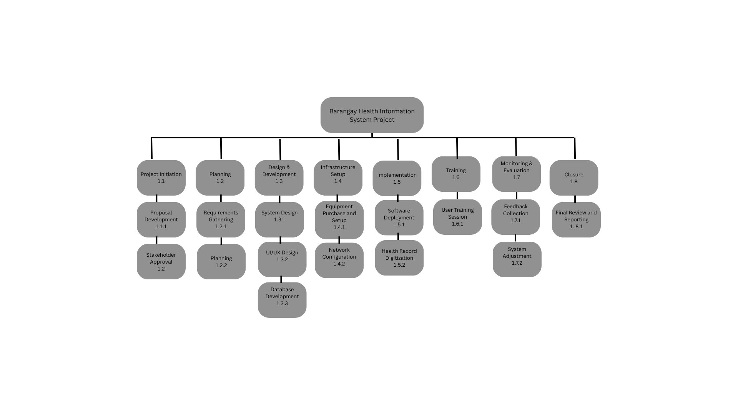

Scope Verification
Deliverables will be reviewed and validated by the Project Manager and Barangay stakeholders. Verification includes:
- User Acceptance Testing (UAT)
- Walkthroughs and demos
- Formal sign-offs from stakeholders

Scope Control
Scope control will be managed through a change control process. All change requests must:
- Be submitted in writing.
- Be assessed by the Project Manager and stakeholders.
- Be approved before implementation.
Unapproved changes will not be executed.

Sponsor Acceptance

Approved by the Project Sponsor:

Date:
Mr. Adrian Joson
Project Sponsor

This free Project Scope Management Plan Template is brought to you by www.ProjectManagementDocs.com

🧩 Barangay Bahay Toro Health Information System

🏥 Modules and How They Connect

1️⃣ Patient Records Management Module (Core)
💡 Central database of all patient information.

Every other module depends on the data here.

Each patient has a unique Patient ID used across the system.

🔗 Connected to:

Health Services Tracking → Uses patient ID when logging consultations.

Reporting & Analytics → Pulls data summaries from patient records.

Data Migration & Backup → Imports and secures patient data.

2️⃣ Health Services Tracking Module
💡 Records all medical services performed by barangay health workers.

Each consultation or treatment links to a Patient ID (from Patient Records).

Records who provided the service, date, and type of service.

🔗 Connected to:

Patient Records Management → Retrieves patient details.

Reporting & Analytics → Sends daily or monthly service data.

User Access & Security → Ensures only authorized health staff can log services.

3️⃣ Reporting and Analytics Module
💡 Generates summaries and official reports for the barangay or LGU.

Pulls data from both Patient Records and Health Services modules.

Produces monthly and quarterly reports.

🔗 Connected to:

Patient Records Management → Patient counts, demographics.

Health Services Tracking → Illness trends, services provided.

Data Backup → Ensures reports can be archived safely.

4️⃣ User Access and Security Module
💡 Controls system access and protects patient data.

Handles login authentication (e.g., Admin, Nurse, BHW).

Restricts access to sensitive data depending on user role.

🔗 Connected to:

All modules → Controls who can add/edit/view data.

Audit trail → Tracks actions done in other modules.

5️⃣ Data Migration and Backup Module
💡 Ensures data integrity and safe transition from manual to digital.

Converts existing manual or Excel-based health records into digital format.

Handles periodic database backups and restoration.

🔗 Connected to:

Patient Records Management → Imports old records.

Reporting Module → Backs up generated reports.

User Access Module → Only authorized admins can restore or back up.

6️⃣ Desktop User Interface Module
💡 Provides a simple and responsive front-end interface for barangay staff.

Connects the user to all back-end modules via PHP and database queries.

Works on low-end PCs and with limited or offline access.

🔗 Connected to:

All modules → Acts as the “bridge” between users and system functions.

